**Product: Mouse that is suitable for gaming and professional work.**

**Name: Micetech**

**Tagline: "Innovation in every click."**

Concept: Micetech is an advanced, innovative, and modern mouse designed to enhance both gaming and professional work experiences. With its precision sensor, ergonomic design, and customizable features, Micetech delivers seamless performance for intense gaming sessions and long hours of productive work. Whether you're coding, designing, or gaming, Micetech adapts to your needs, providing exceptional comfort, speed, and style. Perfect for those who demand high performance without compromising on aesthetics.

AI tool used : Chat GPT , Gemini, Canva AI

**Prompt used to brainstorm the name :**

you are a entrepreneur who want to launch a product which is a mouse

product description: suitable for gaming and professional work

seed words: innovative, modern, stylish ,precise

brainstorm the name of the product

**Prompt used to brainstorm the concept** :

write a short concept for a product of mouse : Micetech . it is a useful for gaming and professional work. it is advance, innovative and modern

**Prompt used to brainstorm the tagline** :

write a tagline for a product of mouse : Micetech . it is a useful gaming and professional work. it is advance, innovative and smooth click feature

**Product logo and design:**

: 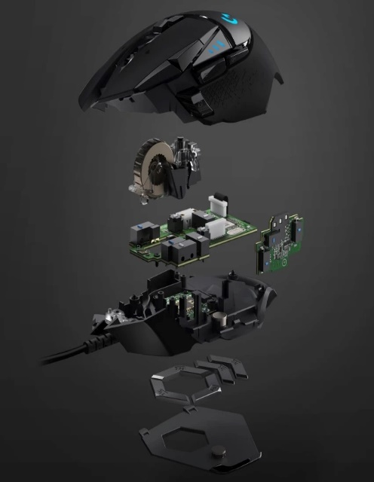

**Prompt use to design logo :**

you are a entrepreneur who want to launch a product which is a mouse named Micetech

product description: suitable for gaming and professional work

seed words: innovative, modern, stylish, sharp features

Color theme: grey,blue

Generate a logo for the product micetech

**Prompt used to design the prototype**

you are a expert web developer tasked to design a website for a product which is a mouse named Micetech

product description: suitable for gaming and professional work

seed words: innovative, modern, stylish

Color theme: grey, black

give the code of html, css and javascript for the website